DeMolay’s Hierarchy of Needs

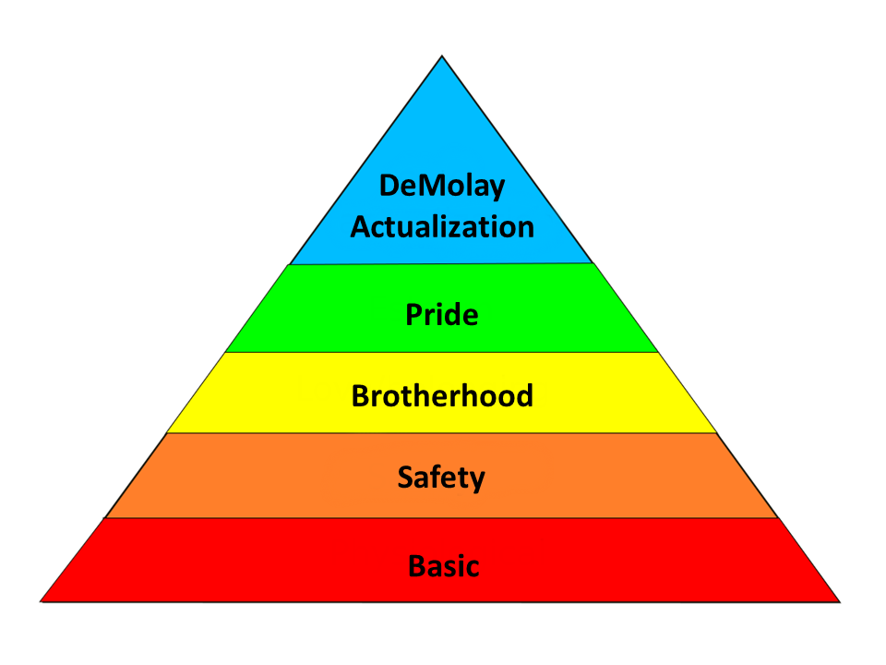

A Guide to DeMolay Self-Actualization

Table of Contents:
Introduction
Step One: Basic
Step Two: Safety
Step Three: Brotherhood
Step Four: Pride
Step Five: DeMolay Actualization

Introduction:

The following, “DeMolay’s Hierarchy of Needs,” is derived from a psychological theory (Maslow’s Hierarchy of Needs) proposed as a tool to help identify Chapter needs for development, growth and “Self Actualization.” In Maslow’s theory, an individual can become Self Actualized, or fulfilled to his greatest potential, only if his more basic needs are first met. Maslow theorized that a person must have base needs met before he is able to move to higher levels of fulfillment. For example, an individual must first have base needs such as food, water and sleep before he can seek safety and shelter. He must have safety and shelter before he can seek love, etc.

Applying this concept on the organizational level, we seek to identify what needs are “base” needs for our Chapters, what resources and people are needed to fulfill these base needs, and in what order. On a fundamental level, being able to identify where a Chapter is on the development spectrum and provide targeted training and stimulation to fulfill the Chapter’s base needs will allow steady Chapter development and prevent regressive motion.

As with any theory or model, the following is subject to experimentation and improvement. Your feedback is welcome and encouraged.

Step One: Physiological/Basic Needs

Maslow’s Definition:
Physiological needs are the physical requirements for proper operation. If these requirements are not met, the human body cannot function properly and will ultimately fail. Physiological needs are thought to be the most important and should be met first. Examples of Maslow’s Physiological needs are: water, food, shelter, clothes, and sleep.

DeMolay’s Basic Needs:
While a Chapter may not have Physiological needs like a human, a Chapter does have some basic needs without which no further development can happen. In no particular order, we have identified to following basic needs:

- Member(s)
- Advisor(s)
- Common Goal / Ideals / Desire to Belong
- Parental Support (for members under 18)
- Meeting Location (Facility)
- “Sparkplug” Catalyst – Individual Driving Progress

What Does This Look Like:
While in this phase, a Chapter will likely have a few members and Advisors who meet once or twice per month for informal meetings. In these base level days, the Chapter is typically held together and motivated by an individual member or Advisor who is motivating the others to be involved. While it is important to seek additional members and Advisors to ensure that the Chapter does not fail for lack of interest, large scale membership recruitment is not the goal of this phase. At this phase, it is most important that the Chapter meet and reinforce DeMolay’s ideal of comradeship. These chapters need fun more than anything else. These boys need to remember why they joined this great youth movement.

Step Two: Safety Needs

Maslow’s Definition:
With their physical needs relatively satisfied, the individual's safety needs take precedence and dominate behavior. This includes protection from elements, security, order, law, stability, and freedom from fear. Once individuals have basic nutrition, shelter and safety, they attempt to accomplish more.

DeMolay’s Safety Needs:
A foundational principal of DeMolay is that we provide a safe and secure environment where each member and Advisor can rely on feeling safe and accepted. For this reason, Basic Needs (Step One) and Safety Needs (Step Two) are essential promises that we make to all DeMolay members. To meet these safety needs, DeMolay on a jurisdictional and Chapter level, must take the following actions:

- Youth Protection Program
- Medical Release Forms
- Advisor Training (formerly DAD Training) / Adult Background Checks
- Insurance
- Upfront agreement of all participants regarding how they can expect to be treated and how they are expected to treat others.

What Does This Look Like:
DeMolay rules and regulations prohibit any DeMolay function or gathering which does not strictly comply with the Youth Protection Standards and our Insurance carrier. Accordingly, a DeMolay function cannot take place under Step One unless Step Two is also considered. A Chapter functioning at this level will look and feel similar to that in Step One, however great care should be made to ensure the safety (physical, emotional, and sexual) of all participants. Advisors will submit to State Patrol background checks and adhere to the Youth Protection Standards. Efforts should be made to ensure that all feel welcome and accepted for being themselves. In this phase of Chapter development, Advisors will continue to take an active guiding role. Advisors need to make sure that Form 10’s are timely turned in via eScribe so the member will be covered under the jurisdiction’s insurance policy.

On a Chapter level, each DeMolay must fill out a medical release form in case of an emergency. Also a semi-annual presentation of the Youth Protection video or suitable alternate presentation should be shown to teach members how to act and protect themselves and others. The Chapter should be seeking opportunities for social and entertaining activities outside of Chapter meetings.

Key Player Responsibilities:

Members: | Seek additional like-minded young men and their parents for recruitment.
 | Offer suggestions for social functions.
 | Attend Meetings and social functions of the Chapter.
Advisors: | Seek additional like-minded young men and their parents or other adults for recruitment.
 | Ensure all potential Advisors and parents have received Advisor Training.
 | Submit Form 10’s in a timely manner via eScribe.
 | Take suggestions from the members, plan and execute social functions.
Direct twice monthly informal meetings of the Chapter. A sample agenda might look like:
- Discuss New and Old Business
- Discuss membership recruitment
- Discuss a Precept per meeting
- Do the 9 o’clock Interpolation
- Close the meeting
Region and State Officers | Seek opportunities to visit Chapter social activities and provide initiation opportunities.
 | Reach out to the individual members and their prospects to ensure that they are feeling included in the DeMolay program and are important.
 | Encourage members to invite their friends to become part of DeMolay activities.
Executive Officer Staff | Provide Advisor Training (Advisor Training for certification as well as skills/ leadership coaching).
 | Work with sponsoring and non-sponsoring Masonic bodies for financial and Advisor support of the Chapter.
 | Follow up with Chapter adult leadership monthly to provide encouragement, resources, and ensure that Form 10’s are submitted.

Step Three: Brotherhood

Maslow’s Definition:
Humans need to feel a sense of belonging and acceptance among their social groups, regardless of whether these groups are large or small. For example some large social groups may include clubs, co-workers, religious groups, professional organizations, sports teams, and gangs. Some examples of smaller social groups may include family members, companions, mentors, colleagues, and confidants.

DeMolay’s Brotherhood Promise:
As a fraternity, the tenant of brotherhood and comradeship is central to the DeMolay identity. DeMolay provides a number of opportunities for individuals to belong, none of which is more important than the Chapter experience. Other opportunities include region and state identifications. Ensuring that members and Advisors feel included and accepted is a paramount objective of the organization. In no particular order, the following steps may be taken to help develop an environment where Chapter members and Advisors will feel accepted:

- Varied Activities. These activities can include Social gatherings, Obligatory Day Observances, Philanthropic/Service, Fundraising, Sports, Meetings, Installations, or Region and State Events. Even within these broader categories, effort should be made to not have every social event be a game night or dance, but rather include other activities that may be of interest to the present members or prospective members. Consider member surveys for understanding the varied interests and diversity of the Chapter body.
- During meetings, members and Advisors should be given roles or opportunities to participate. This can include giving ritual parts / positions, calling on the member to report on past events, or becoming a committee member for a future event. For longer term appointments, providing a job description or outline will help the individual identify with the assignment.
- Participation in Sporting or Ritual Competitions. Sport and competition always allows for team building opportunity.
- Engage in the Leadership Correspondence Course program, study DeMolay History, or Precept Knowledge / Understanding. This will help the Chapter identify as a DeMolay Chapter with a common core.
- Begin travelling to visit local or even distant Chapters. Begin to develop a Chapter, region, state and even international identity (spirit).

What Does This Look Like:
At this level, the Chapter should begin holding Installations. The elected Councilor(s) will begin outlining rudimentary term plans, event plans, and budgets with assistance of the Dad or Mom Advisor. The Chapter should begin to hold Councilor meetings where the Councilors begin to assume responsibility for planning the term and events and directing programs. The Advisory Council should meet monthly and elect their Chair and Dad Advisor annually. Meetings may become more formal and include ritual and paraphernalia. If not previously formed, the Chapter should pass Bylaws. The Chapter’s charter and banner should be displayed at all meetings. The Chapter’s traveling (vinyl) banner should be proudly displayed at all functions outside of the meeting space. The Chapter should take some care in defining roles for the members and Advisors, possibly establishing job descriptions with some accountability. Councilors should be encouraged to seek out opportunities for development such as attending WADA and DLC.

Care should be made to ensure that the Chapter fully develops in this phase before moving on. Because of the short life-cycle of a DeMolay Term (6 Months) and that Chapters ebb and flow with the strength of their Chapter leadership, it will not be uncommon for a Chapter to spend a majority of their time in this phase while occasionally bouncing up to the later stages of development. This is okay and the Chapter leadership should not be discouraged if this is identified. The stronger this base is, however, the easier it will be to rebound to higher achievement levels.

Key Player Responsibilities:

Members: | Seek additional like-minded young men and their parents for recruitment. More effort is given to the task of recruitment, including prospect parties and social events geared toward prospecting.
 | Hold varied activities that encourage involvement of current members (retention) and spark interests of prospective members.
 | Attend Meetings and social functions of the Chapter, region, and state.
 | Hold ritual offices, committee positions, and give reports during meetings.
 | Members should strive to “Prove Up” by completing their obligations.
Chapter Councilors | Attend monthly Councilor Meetings, prepare a term plan including varied activities, prepare a term budget, and plan and execute events.
 | Preside at twice monthly meetings of the Chapter and open and close the Chapter per the DeMolay Ritual.
 | Attend WADA (twice yearly) and DeMolay Leadership Conference (DLC). Complete Leadership Correspondence Course.
Advisors: | Ensure that parents of members are included and informed of opportunities to participate and be involved with their son(s).
 | Ensure that the Chapter is holding varied activities that appeal to the membership.
 | Complete Leadership Correspondence Course, attend WADA, and seek supplemental Advisor training.
Dad Advisor: | Coach the Councilor Corps on preparing a term plan, term budget and planning and executing events. The Dad Advisor should be well aware at this stage in the Chapter’s development that sometimes there is a greater lesson in a small failure than a moderate success.
 | Attend Chapter Meetings and ensure the Chapter is opening, conducting business and closing as the membership and circumstances allow.
 | Help identify quality prospective councilors and encourage them to seek office.
 | Encourage an inclusive and nurturing atmosphere.
 | Work with the parents of the membership to ensure they are informed and know of opportunities for further involvement.
Advisory Council Chairman | Preside at Advisory Council meetings monthly. Ensure that there is appropriate Advisor coverage for events. Complete (electronic) paperwork of the Chapter including Forms 10s and Form 11s on a timely basis.
 | Serve as a sounding board / reference for the Dad Advisor.
Region and State Officers | Seek opportunities to visit Chapter social activities.
 | Attend a Councilor Meeting or Term Planning meeting to help coach the developing Chapter councilors toward success or, at a minimum, to show your support and interest in the Chapter’s success.
 | Provide initiation opportunities / support.
 | Encourage Region and State Event Participation.
 | Encourage members to invite their friends to become part of DeMolay activities.
Executive Officer Staff | Provide Advisor Training (Advisor Training for certification as well as skills/ leadership coaching).
 | Provide supplemental Advisor training for inexperienced Dad Advisors or Advisory Council Chairmen.

Step Four: Pride

Maslow’s Definition:
All humans have a need to feel respected; this includes the need to have self-esteem and self-respect. Esteem presents the typical human desire to be accepted and valued by others. People with low self-esteem often need respect from others; they may feel the need to seek fame or glory. However, fame or glory will not help the person to build their self-esteem until they accept who they are internally.

DeMolay Pride:
A Chapter that has esteem or pride will overcome the largest obstacle to membership growth. Often the biggest hurdle in membership recruitment is to answer the question, “Why would I want to join your Chapter if it is failing?” A Chapter which is proud will naturally overcome this objection before it is asked because the prospect will see the pride of the Chapter through their activities and membership. While esteem is often a bi-product of efficient development in the lower phases identified earlier, the following steps may be taken by a Chapter to help develop positive Chapter Pride:

- Provide opportunity for individual advancement, full Councilor Corps, elections, and a sufficient regular Chapter base to draw talent from for advancement.
- Youth / Councilor led Term Plan / Events.
- Adherence to the PMC-MSA Program.
- Chapter identifies youth / adults for awards and recognition. Establishes Awards program.
- Chapter Ritual and Sport Practices prior to competition.
- Chapter develops a membership / Advisor recruitment program.
- Chapter engages in events with concordant bodies.
- Delegation of tasks from Master Councilor to functioning committees.
- Regular travel to other Chapter meetings and installations.
- Proficient Ritual.

What Does This Look Like:
A Chapter that is functioning with Pride will appear to hit all of the target markers that DeMolay sets in the PMC-MSA program. The Master Councilor will function as the leader of the Chapter, delegating responsibilities and guiding the other members toward a common goal. The Chapter is executing high level, quality, events. The term program and budget will be balanced. The Chapter has established internal training programs for members and Advisors such as a “Big Brother Program” and Assistant Dad Advisor. This may also include passing down term “Event / Program Guides or Bibles.” The Chapter will begin to perform favorably in different competitions. There may be more than one individual running for Junior Councilor. Members may begin to hang out outside of DeMolay functions. Finally, and possibly most telling, the Chapter will retain a dedicated following of members and Advisors who participate with enthusiasm.

Key Player Responsibilities:

Members: | Establish a Chapter visitation program and attend region and state events.
 | Hold ritual offices, committee positions, and give reports during meetings. The members should be using these opportunities to build skills for becoming potential councilors.
 | Wear the appropriate dress for meetings and events (Suit and Chapter tie at meetings, DeMolay t-shirt/polo at casual functions)
 | Develop a “team” bond when competing in sports or performing ritual. Improving ritual performance to the point where the Chapter can host initiations without assistance from other Chapters.
 | Support the Chapter leadership to execute programs and events.
 | Be supportive and encouraging to the other members of the Chapter inside and outside the organization.
 | Be enthusiastic and always have fun whenever at DeMolay.
 | Seek individual recognition / Awards. Representative DeMolay, Blue Honor Key, Merit Bars.
Chapter Councilors | Be the heads of major committees such as Fundraising, Membership, Ritual, and Sports and lead those committees to be successful.
 | Assist the Master Councilor with the completion of the PMC-MSA program.
 | Be enthusiastic leaders to instill fun and enthusiasm to the members of the Chapter so there is a sense of pride.
 | See opportunities to host events with concordant orders such as Rainbow, Job’s Daughters or the sponsoring Lodge.
 | Invite outside Chapters and concordant bodies to events. Ensure Chapter calendar is uploaded to State Website.
 | Seek opportunities for DeMolay involvement in the community.
Advisors: | Every Advisor now has a certain responsibility. There can be an Advisor for ritual, sports, awards, membership, treasury, fundraising, or an Assistant Dad Advisor.
 | They can work with the councilors to build additional programs such as a Big Brother Program, a Chapter newsletter, Recruitment, or Squires.
 | Continue to provide opportunities to build leadership within the members and councilors of the Chapter and be mentors.
 | Seek personal leadership growth for potential advancement to Chapter Advisor or Advisory Council Chairman.
Dad Advisor: | Lead and oversee the Advisors on their responsibilities and provide the assistance they may need.
 | Continue to coach the Councilors on preparing a term plan, term budget, programs, and executing events with their committees.
 | Begin to scout and identify a replacement for Dad Advisor.
Advisory Council Chairman | Preside at Advisory Council meetings monthly. Ensure that there is appropriate Advisor coverage for events. Complete paperwork of the Chapter including Forms 10s and Form 11s on a timely basis.
Region and State Officers | Seek opportunities to visit Chapter social activities and provide mentoring opportunities for the members and councilors in their new committees and programs. This can be the point where these officers are finding potential State Officers to appoint.
 | Provide leadership and enthusiasm to the new members with their presence.
 | Ensure the Chapter is aware of and attends region and state events.
 | Recognize the Chapter for their successes (positive reinforcement).
Executive Officer Staff | Provide Advisor Training (Advisor Training for certification as well as skills/ leadership coaching).
 | Seek candidates for Executive Officer Staff / Region Deputies.

Step Five: DeMolay-Actualization

Maslow’s Definition:
This level of need refers to what a person's full potential is and the realization of that potential. Maslow describes this level as the desire to accomplish everything that one can, to become the most that one can be. This can give realization of personal potential, self-fulfillment, seeking personal growth and peak experiences.

DeMolay Chapter Actualization:
A Chapter that is Self-Actualizing or reaching their highest potential is one that is not only operating successfully in the present (term to term) but also planning for the future and establishing procedures for repeatable success. The goal of a self-actualizing Chapter should be to set stretch goals, expansion of successes to other Chapters, and to start new Chapters. The following steps should be taken by a Chapter that is repeatedly successful in the Esteem phase:

- Establish a Long Range Plan (3 and 5 Year Plan)
- Membership / Advisor growth
- Membership / Advisor retention
- Start new Chapters
- Seek opportunities for public recognition / community support

What Does This Look Like:
A self-actualized Chapter will ultimately be identifiable by whether or not the members of the Chapter reflect the virtues and precepts of DeMolay. DeMolay is an organization designed for development of young men and, accordingly, a self-actualized Chapter will be comprised of members of various ages and maturity levels working toward collective individual improvement.

Key Player Responsibilities:

Members: | Continue to extend the opportunity of DeMolay to others and bring them in.
 | Follow and uphold the retention, membership, and long ranged plan.
Chapter Councilors | Set up social media sites for the Chapter. Ex: Facebook, Twitter, and Instagram. Reach out to community by the newspaper, radio stations, television, appearing in parades, and local schools.
 | Constantly executing and revising membership and retention plans.
 | Design a long ranged plan for the Chapter with the Dad Advisor.
Advisors: | Seek additional adults to receive DAD training to grow the Advisory Board.
 | Execute successful programs and be effective in their specific responsibility.
 | Continue to provide opportunities to build leadership within the members and councilors of the Chapter and be mentors.
Dad Advisor: | Develop with the councilors a long ranged plan for the Chapter.
 | Continue to coach the Councilors on preparing a term plan, term budget, programs, and executing events with their committees.
Advisory Council Chairman | Preside at Advisory Council meetings monthly. Ensure that there is appropriate Advisor coverage for events. Complete paperwork of the Chapter including Forms 10s and Form 11s on a timely basis.
Region and State Officers | Seek opportunities to visit Chapter social activities and provide mentoring opportunities for the members and councilors in their current committees and programs.
 | Provide leadership and enthusiasm to the new members with their presence and terms of office, being the example of what a functioning Chapter and leader should look like.
Executive Officer Staff | Provide Advisor training (“Dad” Training as well as skills coaching).

